

**Python E-Project**

**Hotel Room Booking system**

**Group Members:**

Mursaleen Ahmed

(student id: 1233672)

MUHAMMAD ZOHAIB

(student id: 1205341)

**Project Instructor**

Muhammad Owais

**Submitted to:**

**Aptech computer education**

**Table of content**

1. Acknowledgement.
2. Introduction.
3. Project Certification.
4. Hardware/Software Requirments.
5. Project Duration.
6. Task Sheet.

7.Snapshots.

**Acknowledgement**

We are thankful to almighty, ALLAH that by his grace we have completed our E-project using Visual Studio code for Python.

We are also thankful to our teacher and parents who have guided us in order to complete our E-project. We have sorts of important points into consideration and made the as friendly user as possible. Our fourth E-project in our semester is Hotel Room booking system which we have provided information such as:

Home, About Us, Contact Us, Login, Register, Reservation, super admin login and etc.

Our e-project has been designed and developed using Django and Python with different libraries.

Our main objective is to make as easy as possible for user to interact with our application and to satisfy their needs and info according to their requirement.

We highly appreciate your feedback in the feedback form and your suggestion for further improvement in the near future to improve our website.

**Introduction**

The first for learning, upgrading technical skills and applying the concepts in real life environment at a fast pace is what the industry demand from it professionals today. However busy work schedules, far-flung locations, unavailability of convenient time-slots pose as major barriers when it’s come to applying concepts into realisms. And hence the need to look out for alternative means of implementation in the form of laddered approach.

The above truly pose as constraints especially for our students too! Whit their busy schedules, it is indeed difficult for our student to keep up with the genuine and constant need for integrated application which can be seen live especially so in the field of IT education where technology can change on the spur of a moment. Well, technology does come to our rescue at such time!!

Keeping the above in mind and in tune with our constant endeavor to use technology in our training model, we at Aptech have thought of revolutionizing the way our students learn and implement the concept using tools themselves by providing a live and synchronous e-project learning environment!

**So what is this eproject?**

Eproject is a step-by-step learning environment that closely simulates the classroom and labs based learning environment into actual implementation. It is a project implementation at your fingertips!! An electronics, live juncture on the machine that allows you to

Practice step by step i.e. laddered approach.

Build a larger more robust application.

Usage of certain utilities in application designed by user.

Single program to unifiedcode leading to a complete application.

Learn implementation of concepts in a phased manner.

Enhance skills and add value.

Work on real life projects.

Give a real life scenario and help to create applications more complicated and useful mentoring through email support.

**Project certification**

**This is to certify that,**

**Mursaleen Ahmed and M. Zohaib has successfully designed and developed**

**“Hotel Room Booking system”**

**Date of issue:**

**17-November-2023**

**Date of end:**

**07-December-2023**

**Requirement Specification**

**Hardware**

* A minimum system core i3 3rd generation with 4 GB Ram with installed python and Django.

**Software**

* Visual Studio code(Optional)

**Project Duration**

* **ANALYSIS 14 HOURS**
* **DESIGN 20 HOURS**
* **DEVELOPMENT 17 HOURS**
* **TESTING 8 HOURS**
* **DOCUMENTATION 6 HOURS**

|  |  |  |  |  |  |
| --- | --- | --- | --- | --- | --- |
| NO | TASK | ACTUAL START DATE | ACTUAL DAYS | TEAM MATE NAME | STATUS |
| 1 | **ANALYSIS** | **17-November-2023** | **4** | **Mursaleen, Zohaib** |  |
| 2 | **Design** | **21-November-2023** | **5** | **Mursaleen, Zohaib** |  |
| 3 | **Development** | **26-November-2023** | **8** | **Mursaleen** |  |
| 4 | **Testing** | **4-December-2023** | **1** | **Mursaleen, Zohaib** |  |
| 5 | **Documentation** | **5-December-2023** | **1** | **Mursaleen, Zohaib** |  |
| 6 | **Finalization** | **5-December-2023** | **1** | **Mursaleen, Zohaib** |  |

**Snap Shots**

**Services:**

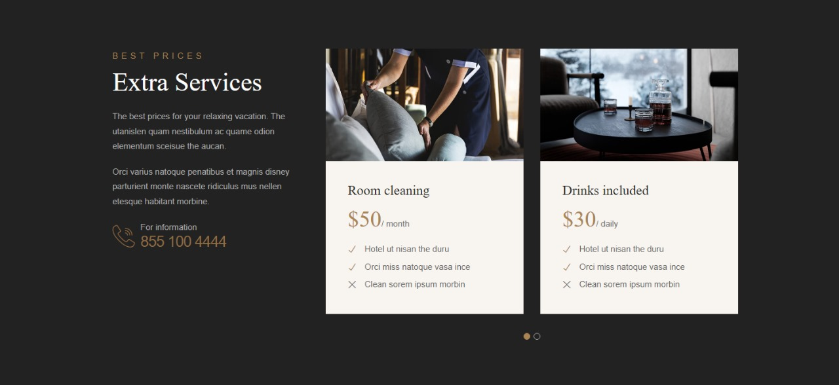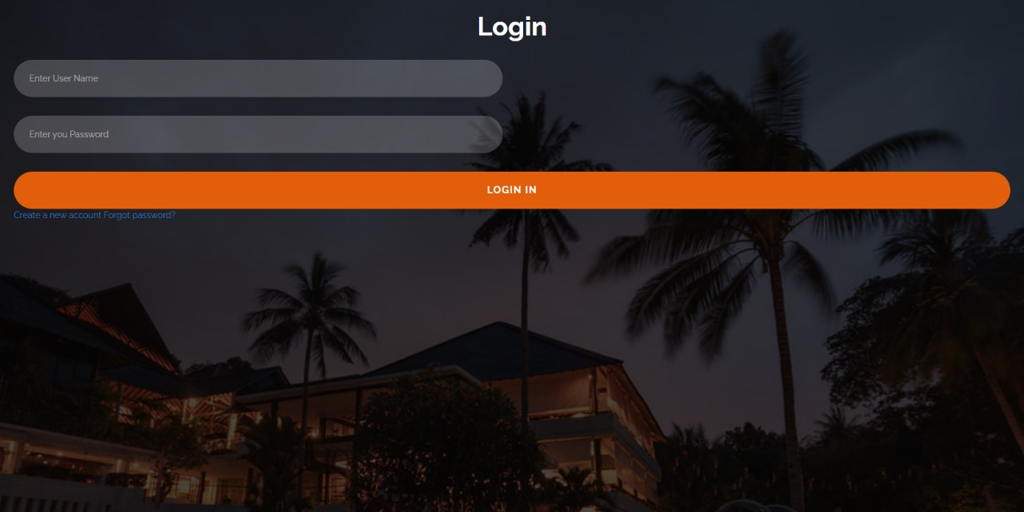**Login:**

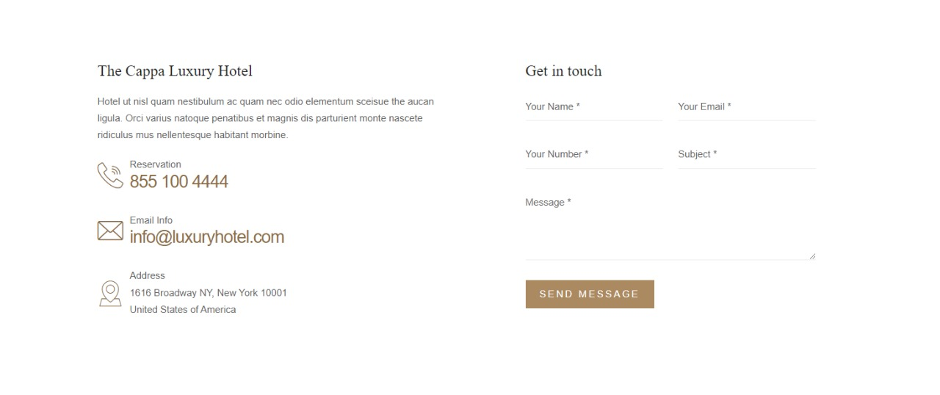**Contact page:**

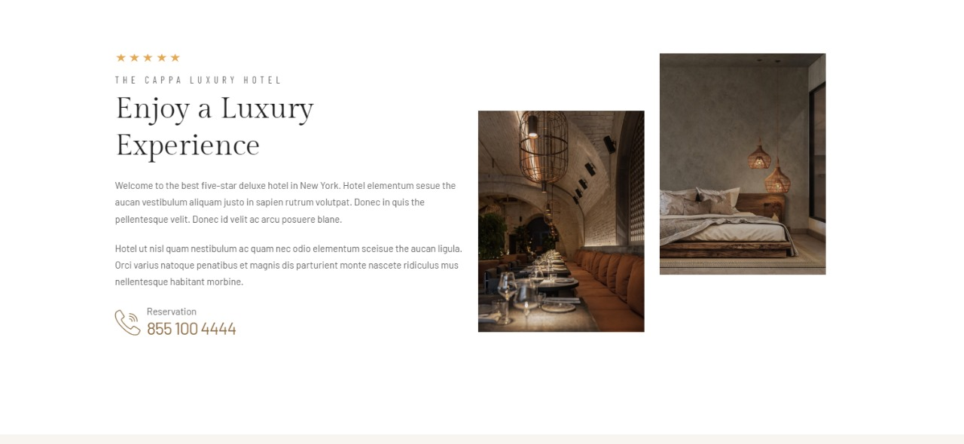**About:**

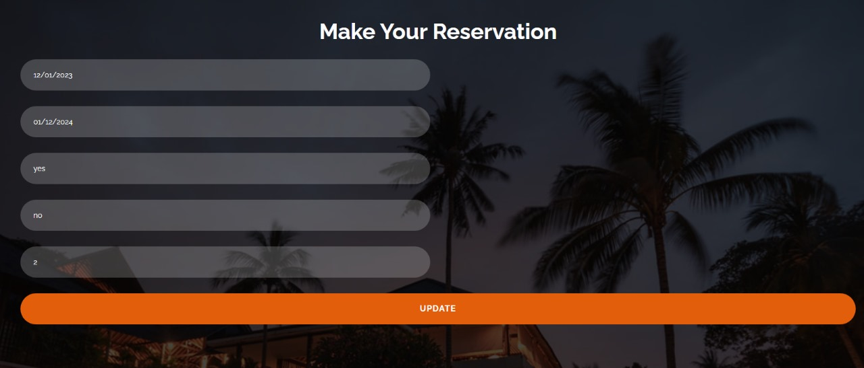**Reservation:**

**Code snippet:**

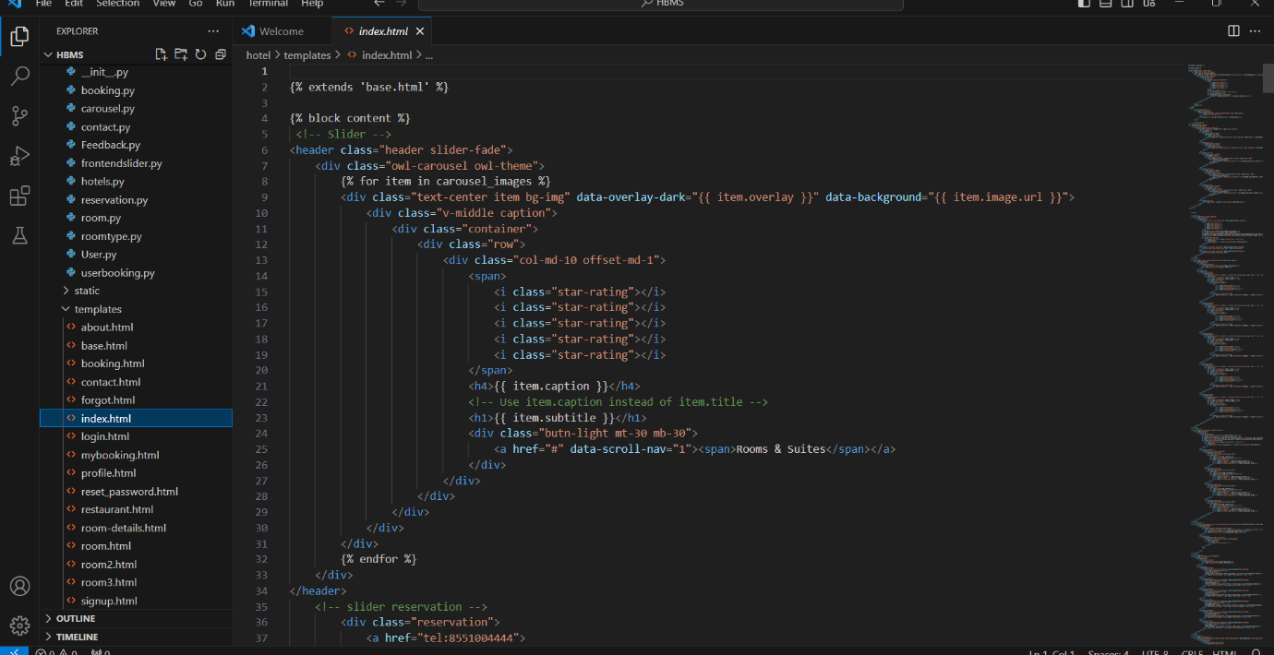**Code: Home page**

**code: settings.py**

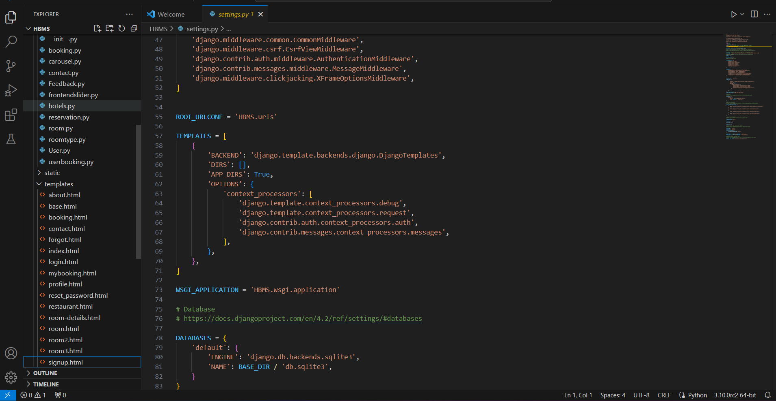

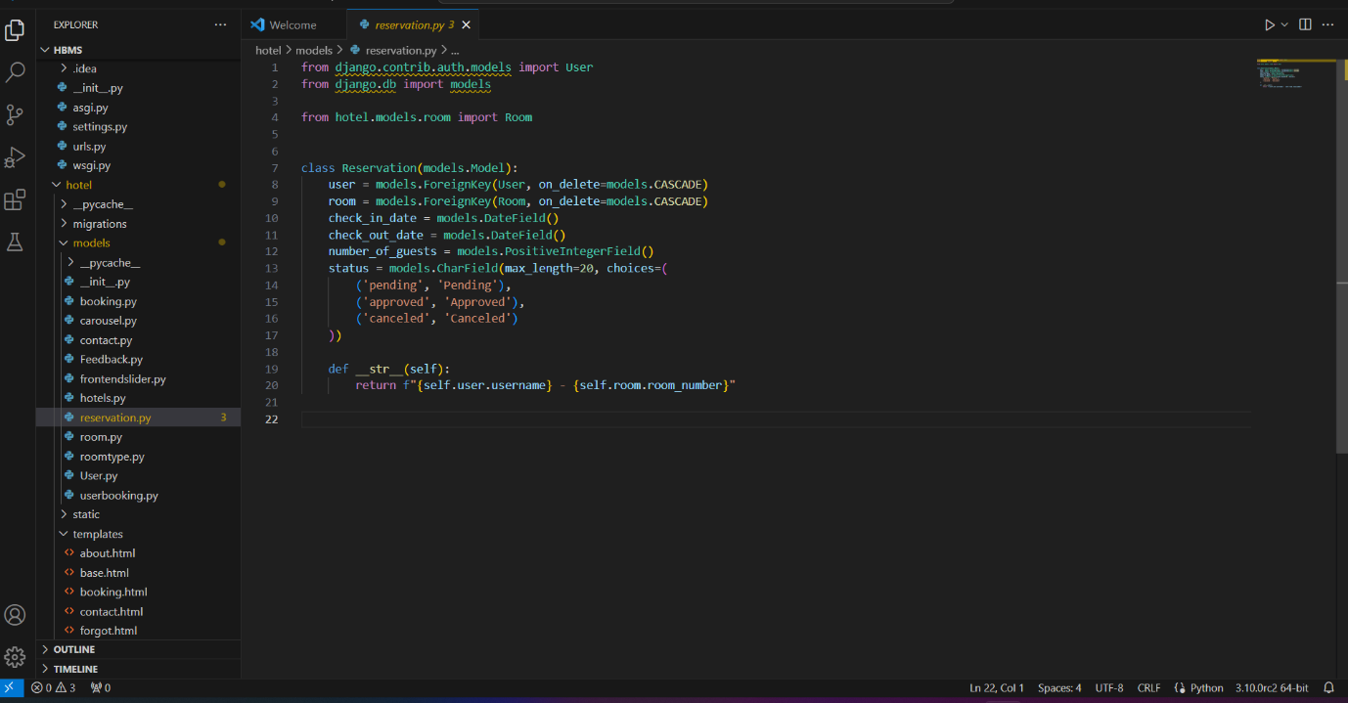**code: reservation.py**

**code: Restuarant.HTML**

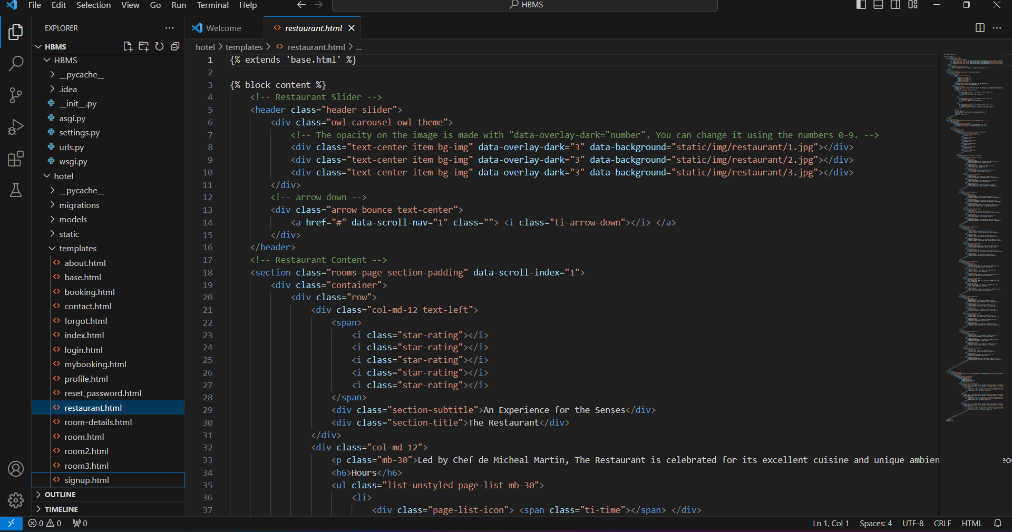

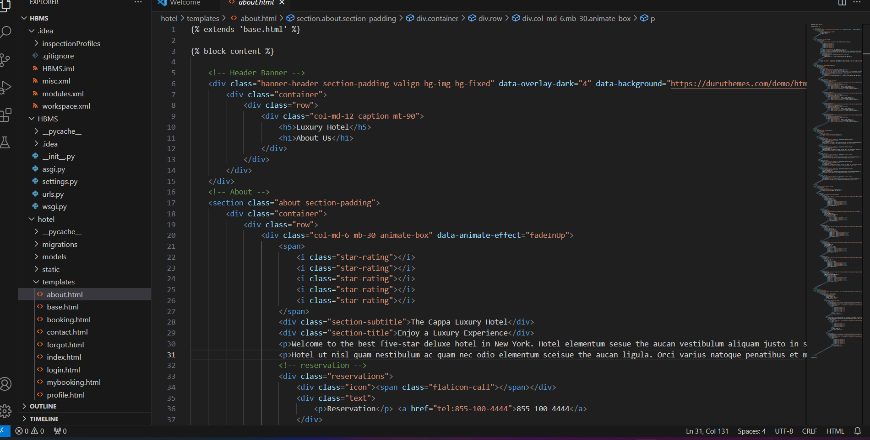**code: about.html**

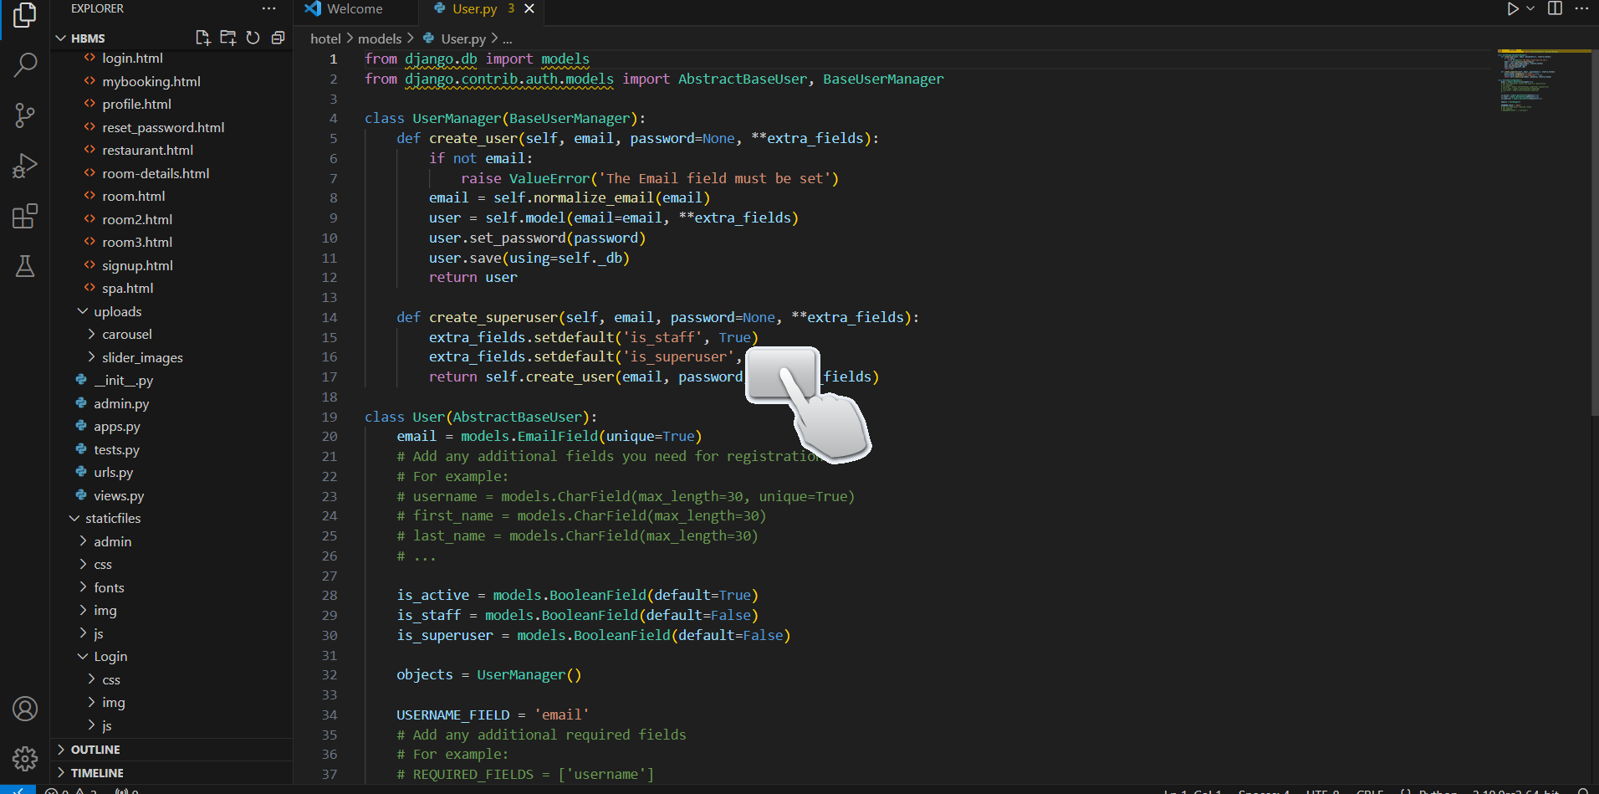**code: user.py**

**code: URLs.py**

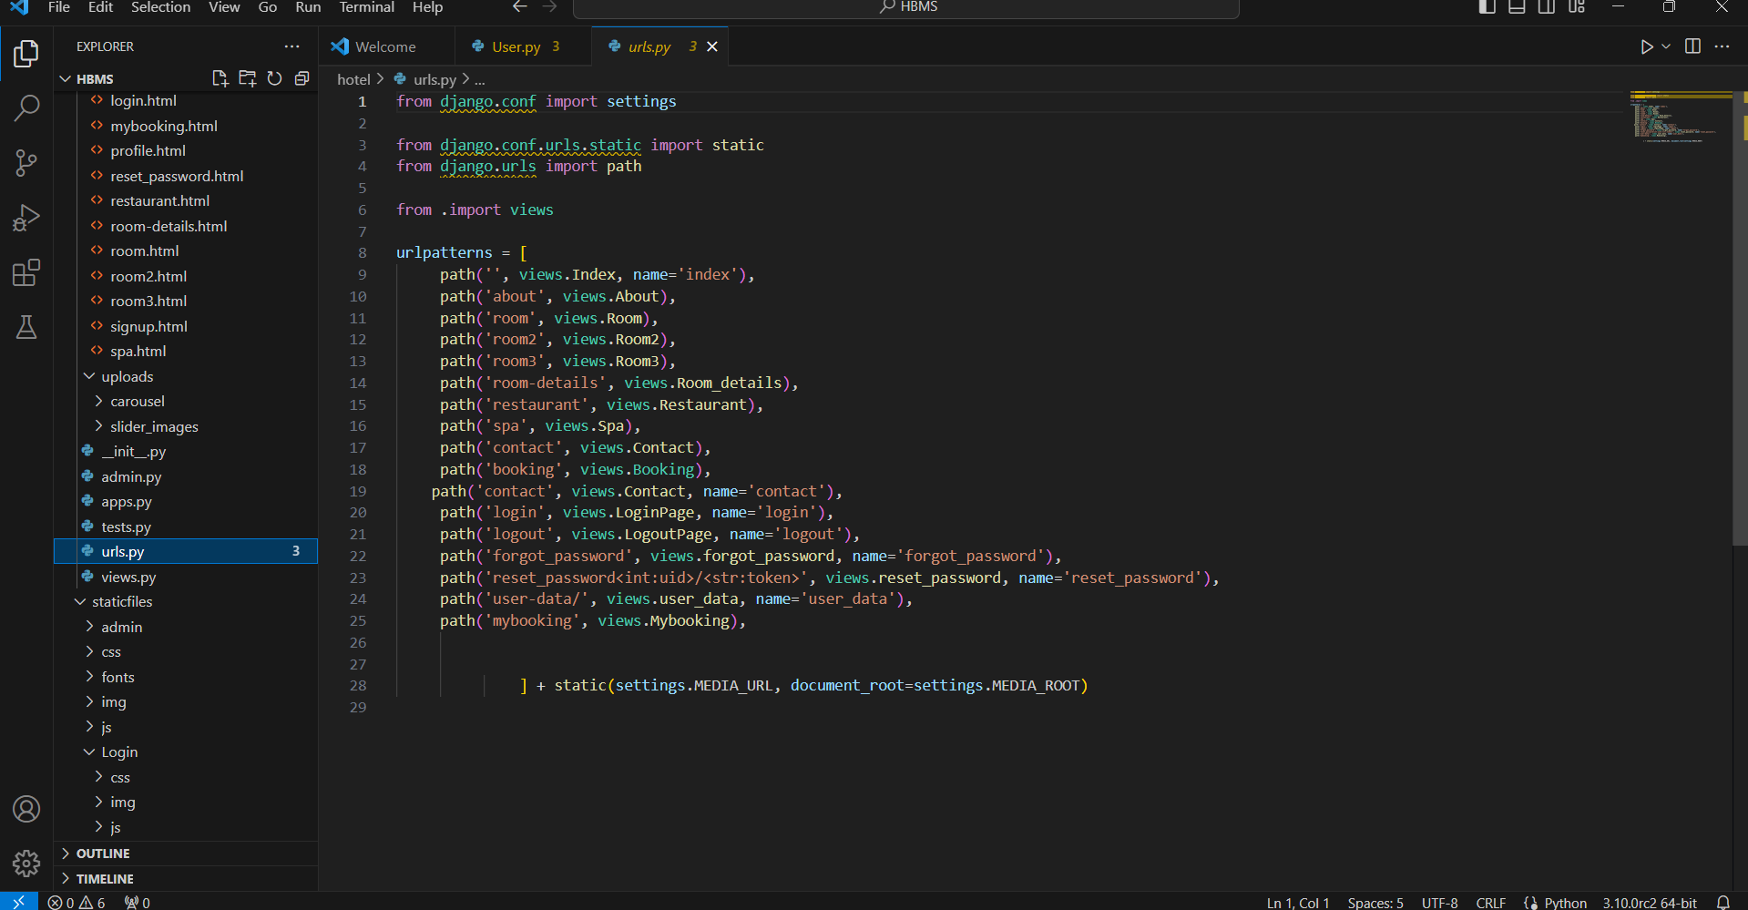

**The Hotel Room Booking System Web App building is done**.

**Android E-Project**

**“HBMS”**

**Group Members:** SUBMITED TO :

Mursaleen Ahmed PROJECT INSTRUCTOR:

(student id: 1233672) “**M. Owais**”

MUHAMMAD ZOHAIB CURRICULUM CODE:

(student id: 1205341) **1907G**

**Our Web App name:**

“**HBMS”**